

How to turn off water to a toilet

As with most plumbing fixtures, toilets come with a built-in shutoff valve. In most cases, the shut off valve is located within the toilet’s primary water supply. It is going to be located attached to the wall, closer to the floor and will look like this

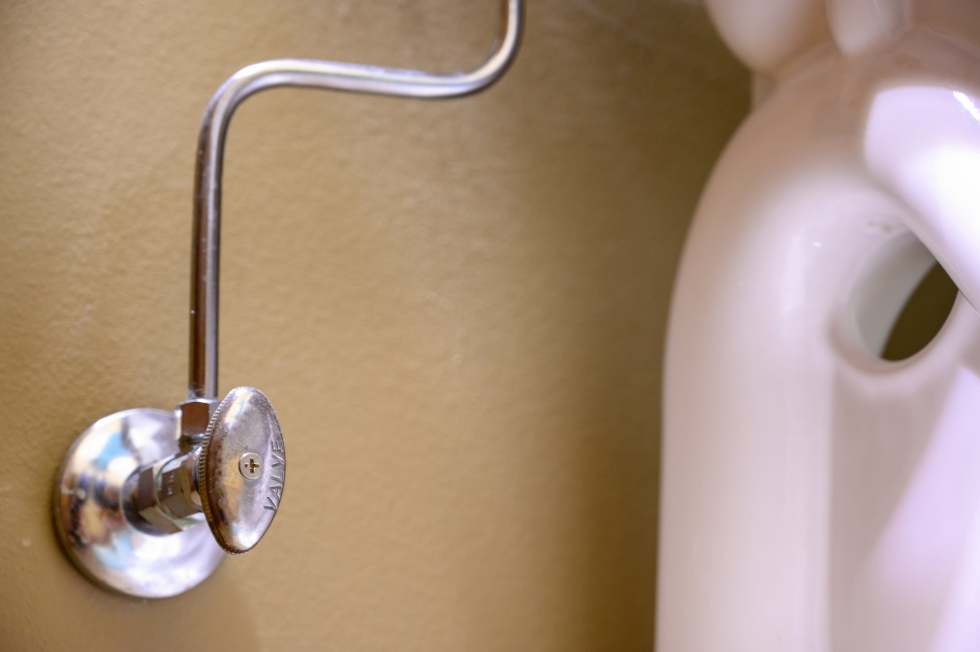

To shut it off turn the valve clockwise as far as it can go. Do not turn it too tight, just turn it until it stops and you will hear the running water stop flowing. Once you hear the water running stop, you have successfully turned off the water and this will be crucial in preventing further damage and unnecessary repairs as well as minimizing your water bill until the repairs can be made.

