
Creating a service issue via tenant portal

Log into the portal, your log in information is the same that you created when you applied online
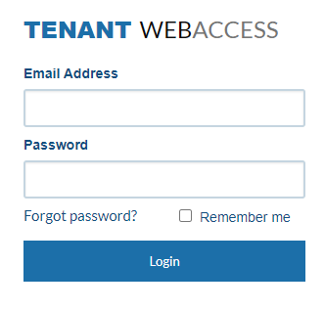
On the top of your screen select “service issues.”
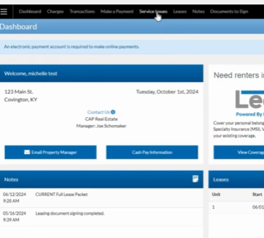
This tab will show you all service issues you have submitted
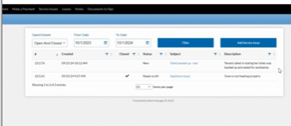

To create a new service, select “add service issue” on the far right of the screen
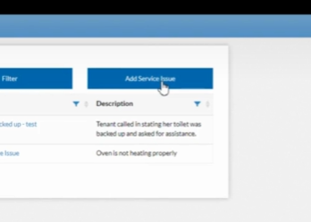
Enter the phone you can be reached at as well as what the issue category is from the drop-down menu with a description of the issue:
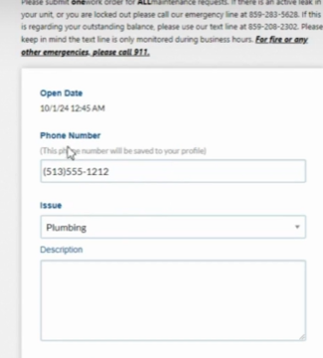

Type of issues in drop-down:
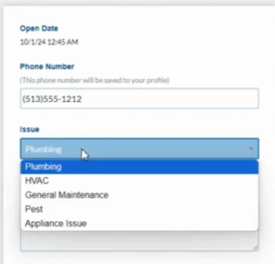
After you fill out the description you can even upload pictures, which always helps us understand the issues:
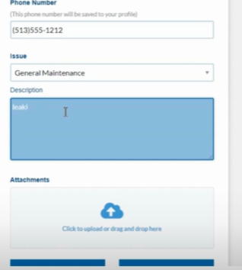

Once you have completed the above steps select “Submit” in the bottom left corner of the screen and you have successfully submitted a work order via the online tenant portal
