**Trouble shooting electric (how to check a tripped breaker)**

One of the most common (and easiest things to eliminate as a cause) when you lose power to a light or electrical outlet is to check the electric panel to see if you have a breaker that is tripped.

* The first step is to locate your panel. This can be in the basement, hallway, bedroom closet or kitchen. It Is going to look something like this below:

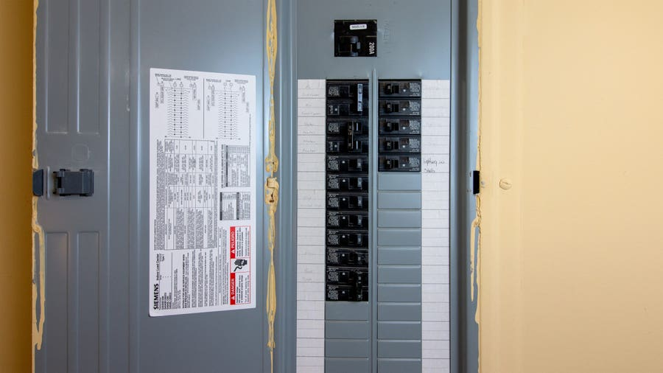

* Next turn off all the light switches and unplug appliances in all rooms without power.
* Then you need to go back to your electric panel and open the cover
* Locate the tripped circuit breaker. Remember these are small, usually horizontal switches that may be labeled (Kitchen, bathroom, water heater). The tripped breaker will be in the “off” position or in a middle position between “on” and “off.”
* Reset the breaker by moving it to the full “off” position and then back to “on.” That should clear an overload and return power to the room(s).
* If the breaker re-trips, it could be for several reasons. It could be a damaged receptacle, outlet, or too many things plugged in. If this is the case DO NOT RESET AGAIN and call maintenance immediately.

**WARNINGS:**

If a breaker continues to re-trip, you should call emergency maintenance

When resetting the breaker, use only one hand and stand to the side to avoid electrical arching if the breaker should malfunction.

Working with electrical systems is potentially dangers, DO NOT PEROFRM ANY MAINTENANCE ON THE ELECTRICAL SYSTEM.