*Downloading the RM Resident App*

Go to your phone’s app store and search “rmResident.” It will look like this

Once you down the app you will need to enter the company code of cinciap

After you hit the code hit next and you will go the log in screen. Here you will enter your user name and password, which was provided to you with your tenant portal log in, it is the same password

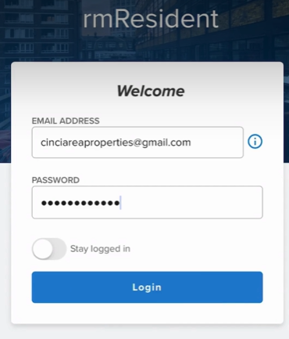

**Then that’s it. Your rm Resident app is activated.**